**Dissertation Outline**

**Live IOT machine data using Augmented reality.**

**Submitted By:**

Name : Aravind Prabhu

Roll No : 2017SP93044.

Email Id : aravind.prabhu@sap.com

Mobile No : +918105650450.

**Under the supervision of**

Name: Sumeet Raj

Role: Senior Developer

Qualification: M.Tech in Information Technology

Experience: 12 Years

Email Id: sumeet.raj@sap.com

Mobile No: +91 9886419683

BIRLA INSTITUTE OF TECHNOLOGY AND SCIENCE

Pilani (Rajasthan) INDIA

February 2019.

**Problem Statement:**

As the data in the world is exploding drastically, now data has become power. Also, the way we can access data also has changed over time. Now everyone has so much computation power in their hand that everything they need is available at a single click.

But even then, to get some information we must search online and surf through lots of webpages just for a simple task in like getting price of an item. In business domain also, we must go to a monitoring dashboard and do many clicks to know the to get current state of machine which is in front of you. So, this is an overhead which can be avoided and can be improved to make life easier.

**Objective:**

The main objective of the project is to make peoples life easier and to improve the business process. With the help of augmented reality now we can see the live data of a machine and know its state. So, this will help in maintenance of the machineries and to speed up the business process. There will be 8.4 billion connected things in 2017, setting the stage for 20.4 billion Internet of Things (IoT) devices to be deployed by 2020, according to analyst firm Gartner. So, with IOT and Augmented reality together we can get the information about the device/machine in front of you with ease and it will help in improving the efficiency of the business process .Smart engineering processes can save manufacturers millions of dollars by [identifying potential flaws in products](https://www.hpe.com/us/en/insights/articles/the-real-world-of-virtual-reality-training-1710.html) before they ship, in addition to reducing the time to ship a product. Using AR and IoT sensors, engineers “can virtually see what’s going on inside”.

**Uniqueness of the project:**

There are solutions focused on IOT or Augmented reality but their adoption in industry is very less. There are some solutions offered by companies like ptc and [L2 Technology Services](https://www.youtube.com/channel/UCcjAm1HcN2Df3-2lrcHeroQ), but they are focused on the process of fixing/repairing of the equipment and not on the machine details at current time. The idea in this project is to make an AR solution which can integrate to any type of IOT device.

**Benefit to the organization:**

SAP is leading in terms of adapting unique and upcoming technology solutions to help the world run better. There is currently no solution combining both IOT and the Augmented reality. Also, this coincides with SAP’s vision that is, to help world run better and improve people’s life.

**Scope of Work:**

The Augmented reality will be an Android app which will communicate with this Gateway service that will be deployed on Cloud foundry to get the data. Also, Hardware sensors will be used to send data to gateway. So main scope of this project is the Augmented reality application showing the IOT data .The IOT sensor and the gateway services that will be built will help in showing the end to end scenario of the application.

**Resources Needed:**

|  |  |
| --- | --- |
| Software (Frameworks, Cloud platform) | 1. Unity/Vuforia framework. 2. Spring boot. 3. Cloud Foundry Account. 4. C# |
| Hardware | 1. Any Windows PC 2. Hardware sensors |

**Potential challenges and Risks:**

1. We are going to deploy our IOT Gateway service to in cloud platform, so there might be an issue in terms of data access when the cloud is down.
2. Making the android app efficient to get the real time data.
3. Choosing current AR framework to work with android.
4. Potential challenges in managing IOT sensor data.
5. Time required to learn and adopt the Augment reality framework.

**Solution Architecture:**

The application will have an android application and an IOT Gateway service. The gateway service will be built and deployed on SAP Cloud Foundry Environment. The Hardware sensor will communicate with this Gateway service and this service will communicate with the Android application. The persistence of the IOT data is optional and its based on the need. So as soon as the sensors push the data onto the IOT Gateway service the data can be stored based on the requirement. And the real time details of the data of the sensors can be visualized using the Augmented reality application.

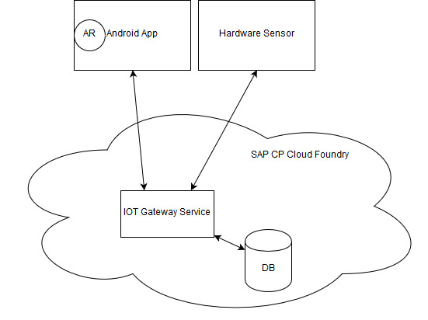

Fig 3. Proposed Architecture

**Plan of work:**

|  |  |  |  |
| --- | --- | --- | --- |
| **SLNO** | **Task** | **Expected date of completion** | **Names of Deliverables** |
| 1 | Research and feasibility validation | 25-02-2019 | Research |
| 2 | IOT service deployed to cloud foundry | 20-03-2019 | Gateway Service |
| 3 | Augmented Reality application development | 20-04-2019 | Application |
| 4 | Integration of Augmented reality app to IOT service | 20-05-2019 | Integration |
| 5 | End to End Demo | 29-06-2019 | MVP |